Log onto your ePals Account.
Click on the Monitored Mail Tab. This is where all information about your students’ accounts is housed. This is also where you will go to approve your students’ mail. You have
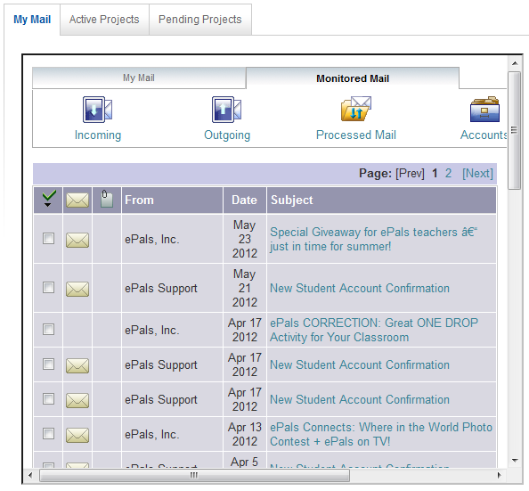
Incoming Mail: This will be mail that is arriving from ePals for your students. When there are messages here, you will have to read them and approve them before they reach your students.
Outgoing Mail: This will be mail that your students have written to their ePals. You will have to read and approve this mail before it reaches the ePals.
Processed Mail: Once you have approved mail, it moves from your Incoming or Outgoing Box, and is stored here. You may need to go through and empty this box, depending on how many emails your students write. It is nice for you to keep a copy, when possible, because student accounts do not save mails automatically. When they send email, unlike regular mail, a copy isn’t saved in their mailbox. It is only saved in your processed box.
Accounts: This is where you can find a list of your student accounts. (see more below).
Filter Settings: ePals offers 4 levels of filter settings for student email. Currently, all your accounts are set on Level 1 – which is the most restrictive. I will put more information on Filters below. However, if you want to keep your accounts on Level 1, which provides the most security for students, you won’t need to read that information. You should know that you can change Filter Levels per student; you are not required to have the same setting for all students in your class.
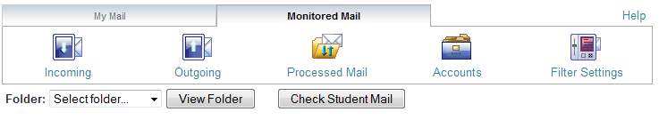
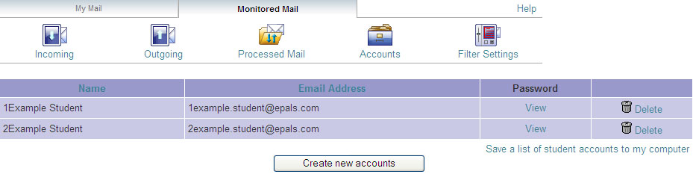
Accounts: This is where you will find all of your student accounts. ePals may have created generic accounts for you (based on teacher last name) or you may have created your own, based on student name. If you have generic accounts, you will probably want to keep a list of student name assigned to each account.
Name: This is our generic equivalent for student name. Currently, you cannot change this to add in a specific student name. (We are currently developing this function.)
Email address: This is your student’s username. When he/she signs into ePals, he should type everything before the @epals.com.
Password: You may view student passwords to remind them if they have lost theirs. You cannot change student passwords, but they can once they have logged in.
Delete: If you want to get rid of an account, just click this button

MODERATING MAIL (INCOMING/OUTGOING/PROCESSED)
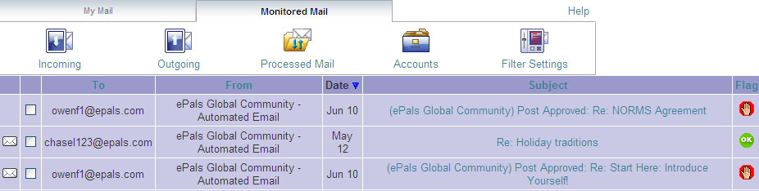

When you have a mail to moderate, please click on the Subject line.
Read the email.
- If you click Approve – it will go to the intended recipient.
- if you click Delete – it will delete. You will have to alert your student that you rejected the email.
- You can Reply to outgoing mails (those from your students). In doing so, you can explicitly tell students what they need to fix. They will have to block and copy the email to put it into a new email form and send again.

YOUR STUDENTS: LOGGING ONTO EPALS
Go to www.epals.com
Sign in with student username (example: 01freeese.lrhs) and password.
First time a student signs in, he/she must input his/her birthday. This is required by federal COPPA law. We don’t use the birthday anywhere on the site. It tells us how we must treat data about the student (law requires different treatment of students under the age of 13).
Once they have logged in, here are several areas students can explore freely, without any teacher input needed.
- Student Learning Centers: There are 6 different student-driven centers, where your students can work independently with other students. Teacher participation is not required. All content is moderated
- Student Forums: Chat with kids around the world about a wide variety of topics.
- Student Media Galleries Work from students around the world, including:
  - Featured Photos
  - “Where in the World Photo Contest”
  - Presidential Minute
  - Smithsonian Student Work
  - We are ePals”

